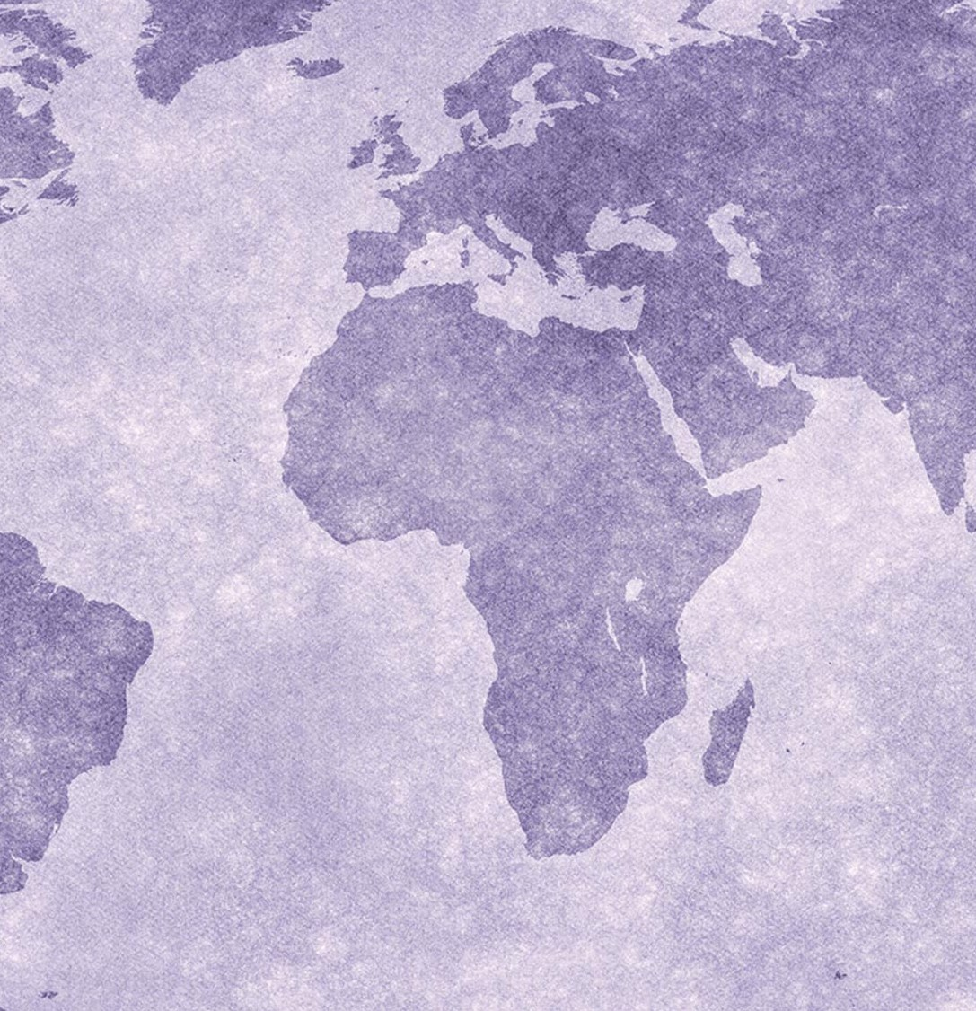
Women Enabled International
www.womenenabled.org

2016 Annual Report

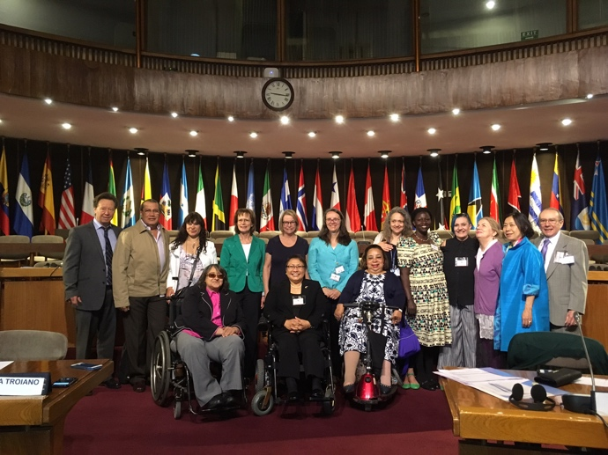

Photo: Expert Group Meeting Women with Disabilities - Development & Society Santiago de Chile in November 2016. The Division for Social Policy and Development (DSPD) of DESA co-organized with the United Nations Economic Commission for Latin America and the Caribbean (UNECLAC) in Santiago de Chile.

Who We Are

Women Enabled International (WEI) is a global not-for-profit organization that works at the intersection of women’s rights and disability rights and advocates for the rights of women and persons with disabilities, with a focus on the rights of women and girls with disabilities in collaboration with women’s rights and women with disabilities rights organizations worldwide. Through such collaborations, WEI focuses on human rights programming and training in developing, and post-conflict countries, as well as consulting for governments, non-governmental organizations (NGO’s), and international organizations to ensure the inclusion of women and girls with disabilities in international policy and development program design and implementation.

WEI has highlighted the impact on women and girls with disabilities of issues such as violence against women, sexual and reproductive rights and health, access to justice, education, employment, and development policy. Additionally, WEI takes these principles and implements them on the ground through in-country projects and collaborations with partners.

WEI has established collaborative partnerships with organizations of women and girls with disabilities including, Sisters of Frida (UK), India Network of Women with Disabilities, Africa Network of Women with Disabilities, Women with Disabilities Australia, Disabled Women’s Network (DAWN) Canada, National Union of Women with Disabilities of Uganda, The Association of Disabled Women ONE.pl (Poland), MC Mobility Challenge (Macedonia), Shanta Memorial Rehabilitation Center (India), Inclusion International Lebanese Association for Self-Advocacy, Legal Defence and Assistance Project (Nigeria), Women with Disabilities Arts and Cultural Network (South Korea), Handicap International (Global) and Point of View (Global), among others through which WEI collaborates in the preparation of shadow reports on the rights of women and girls with disabilities, supporting the development of new such organizations, and drafting policy papers. Similarly, WEI partners with women’s rights organizations such as Center for Reproductive Rights (Global), CREA (India), and the Women’s Refugee Commission (US).

Since its founding in 2012, WEI has grown to a staff of nine and it is recognized worldwide as unique, innovative, and groundbreaking, and WEI has made significant achievements during 2016.

WEI Board, Counsel and Staff

- WEI has a dynamic group of board members:
  - Stephanie Ortoleva, President (United States)
  - Andrea Parra, Vice President (Columbia)
  - Frances (Frank) Della-Penna, Treasurer (United States)
  - Jagoda Risteska, Member (Macedonia)
  - Asha Hans, Member (India)
  - Carissa Janis, Member (United States)

- WEI continues to expand upon their Advisory Council:
  - Harilyn Rousso (United States)
  - Jolly Acen (Uganda)

- WEI’s Team is growing with paid employees, consultants and volunteers:

  - Stephanie Ortoleva, President, Founder and Legal Director
  - Suzannah Phillips, Senior Legal Advisor
  - Anastasia Holoboff, Legal Advisor
  - Amanda McRae, Legal Advisor
  - Meaghan McMahon, Development and Projects Advisor
  - Jessica Hulse Dillon, Program and Office Coordinator
  - Amy Pace, Consultant Web Woman and Graphic Artist
  - Si Kailian, Bookkeeper
  - Ashley Pusey, Social Media Director

Major Funders

WEI’s Fundraising efforts in 2016 have resulted in a substantial increase in WEI’s revenue from the following major funders:

- Anonymous donor for work on organizational capacity building, for the Survey and Mapping Project, and for the Convening of disabled women’s rights advocates in Geneva, Switzerland in July 2016.

- Channel Foundation for the development of and training on WEI’s accountABILITY toolkit.

- Open Society Foundations for training on WEI’s accountABILITY toolkit, holding a convening of disabled women’s rights advocates in the Americas, collaborating with partner organizations in researching and drafting shadow reports and other submissions to U.N. treaty bodies and other mechanisms.

- UN Population Fund for developing a Standards and Implementations Tool for Service Provision for women and young people with disabilities regarding sexual and reproductive health and rights and gender based and sexual violence.

- The Combined Federal Campaign, a workplace giving program for U.S. government employees.

Current Projects

- Enabling a Global Human Rights Movement for Women and Girls with Disabilities: Global Disabled Women's Rights Advocacy Report (March 8, 2016), available at: http://womenenabled.org/mapping.html

WEI's Mapping Report is the first-ever report and map of the movement for the rights of women and girls with disabilities. The mapping of the field of high-level advocates for the rights of women and girls with disabilities globally, nationally, and locally was completed through surveys and interviews producing a comprehensive report and basic database. This “map” or “landscape” provided not only a sense of the scope and depth of the growing field of disabled women’s rights organizations and high-level advocates for disabled women’s rights, but also serves as an empowering organizing tool to share strategies. As many of these leaders work in isolation in their countries’ disability rights and women’s rights communities. Awareness of and connections to other similarly focused organizations and advocates, addressing the rights and empowerment of disabled women and girls around the world, is an empowering resource for better collaboration and organizing. WEI released this Report on March 8, 2016, International Women’s Day, but we continue to update the map and database as we learn of new organizations.

- accountABILITY Toolkit: Through funding from the Channel Foundation and with the assistance of several private pro bono law firms, WEI’s President and Senior Legal Advisor continued drafting WEI’s groundbreaking ‘accountABILITY toolkit’. This toolkit will provide disabled women’s rights advocates with strategies and resources to advocate before United Nations mechanisms. The accountABILITY Toolkit consists of a series of briefing papers, shared with participants at WEI’s Convening in July 2016 in Geneva, Switzerland, and then again at the AWID conference in September 2016 in Brazil. The initial draft of the advocacy guide includes the following four briefing papers:
1) An Introduction and Advocacy Guide,
2) The Right of Women and Girls with Disabilities to be Free from Violence,
3) The Sexual and Reproductive Health and Rights of Women and Girls with Disabilities, and
4) The Right of Women and Girls with Disabilities to be Free from Stereotyping and Discrimination

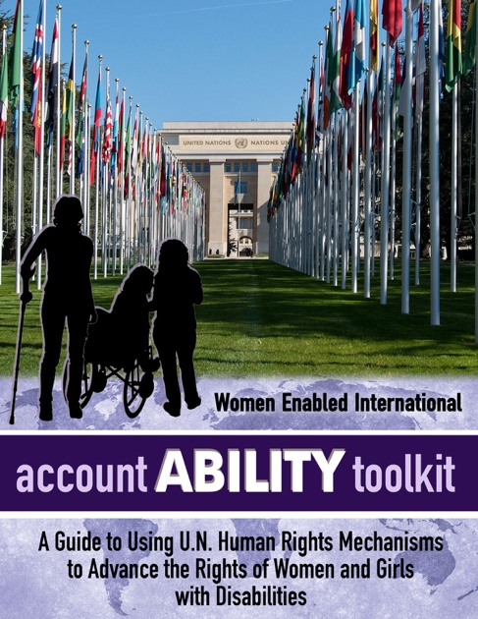
WEI’s ‘accountABILITY toolkit’ will then be finalized by early 2017 before the second Convening in South America in late spring or early summer 2017, and will continually be updated with new information and strategies, as well as input and feedback from disabled women advocates and their allies. WEI’s accountABILITY toolkit will be posted on WEI’s website, distributed through our e-mailing list and to women’s rights and disability rights list serves, distributed on flash drives at conferences and other venues, along with a limited number of print copies. Additional human rights issues will be covered in future editions as WEI continues to pursue funding for the expanded development of WEI’s accountABILITY toolkit.

- WEI undertook extensive research on available human rights advocacy training and found that currently available human rights advocacy training either focuses on only one U.N. human rights treaty or marginalized population. For example, a few organizations offer training to women’s rights advocates, but such trainings do not include disabled women, nor address their issues, and mainly focus on the U.N. Convention on the Elimination of All Forms of Discrimination Against Women. A very limited number of other organizations offer training to disability rights advocates, and although disabled women advocates may participate, the focus of such trainings is on disability rights generally, without the gender focus, and mainly concentrate on the U.N. Convention on the Rights of Persons with Disabilities. WEI’s accountABILITY toolkit is innovative in that it focuses on seven of the human rights treaties and addresses these treaties from the perspective of the rights of disabled women and girls.

- WEI Convening of Advocates for the Rights of Women and Girls with Disabilities: WEI’s first convening took place from July 11-14, 2016 in Geneva, Switzerland. This meeting of international disabled women’s rights leaders clearly helped them to better understand the scope and depth of the field of the rights of women and girls with disabilities. Through WEI’s intensive training, the convening enabled them to engage in vigorous international advocacy and collectively develop strategic actions based on shared learning and collaboration. This convening helped to empower and consolidate a Collaborative Partnership of women’s and disability rights advocates and allies who can work together when opportunities arise to shape policy in international bodies advancing the rights of women and girls with disabilities. Below, a photo of the convening participants.

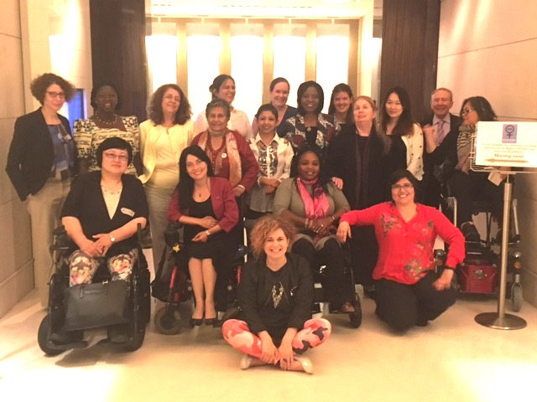

Participants received intensive training on international human rights law and advocacy, using WEI’s accountABILITY toolkit. Following this first convening and in response to demand from participants and other groups, WEI has already collaborated with participants from India and from the United Kingdom to jointly develop and submit shadow reports on their countries as part of the U.N. Universal Periodic Review, addressing issues of gender-based violence, sexual and reproductive health and rights and access to justice. WEI is also working with participants from Nigeria to prepare a submission to the CEDAW Committee for Nigeria’s upcoming review to prepare a ‘List of Issues’ addressing the same topics. WEI hopes to pursue similar partnerships with other participants in the future. Additionally, WEI is planning another convening in South America in late spring or summer 2017 and, with additional funding, we hope to hold a Convening in Africa, as well as other regional Convenings in South Asia, South East Asia, and the Middle East/North Africa, dependent on receiving additional funding.

- WEI and UNFPA Standards and Implementation Tool: UNFPA engaged WEI to research and draft the Standards and Implementation Tool to provide guidance for key stakeholders on the provision of quality, human rights-based sexual and reproductive health services and gender-based violence services for women and young people with disabilities. The purpose of the tool is to provide practical and concrete guidance to key stakeholders who develop and implement programs, policies, and laws around access to sexual and reproductive healthcare and gender-based violence, with a particular focus on service providers, to ensure that such efforts conform with State’s human rights obligations to respect, protect, and fulfill the rights of women and young people with disabilities in these crucial areas. Further information on the Tool can be found here: http://womenenabled.org/unfpa-wei-tool.html

- WEI, in collaboration with The UN Population Fund (UNFPA) held an Expert Group Meeting on the Development of the UNFPA/WEI Standards and Implementation Tool for services regarding sexual and reproductive health and rights and gender-based violence for women and young people with disabilities, in Cartagena, Colombia on December 6,7, and 8, 2016. To ensure that the tool is developed through a comprehensive consultative process with experts from the global community, this Expert Group Meeting brought together professionals in health, including sexual and reproductive health and rights, and/or gender based and sexual violence, from both policy and practice perspectives. Invited stakeholders included leading international disability rights experts, representatives from relevant U.N. agencies, and representatives from specific selected countries, among others. Below on the left is a phot of all of the panelists sitting at a table and on the right is a photo of the three attorney members of the WEI team preparing for their presentation.

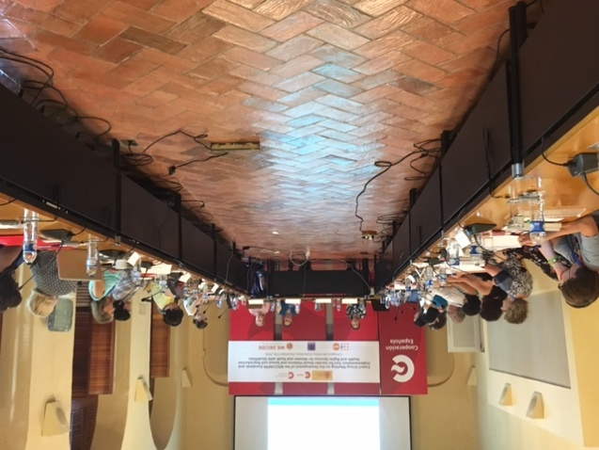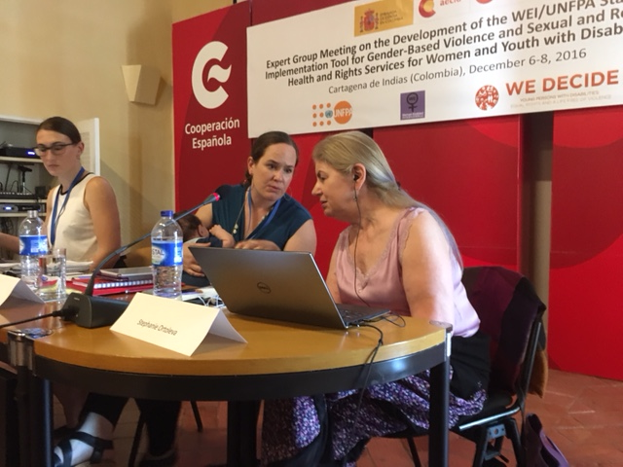

Presentations and Speaking Engagements

- In January 2016, Stephanie Ortoleva was named one of Women’s E-News 21 Leaders for the 21st Century in 2016. Stephanie was recognized as a leader who “…has made it her mission to change the rules that constrict the lives of women and girls across the globe.” An article about the recognition can be found here: http://bit.ly/1KlJWD3
Stephanie attended the award ceremony in New York City on May 2, 2016. Below is a photo of Stephanie holding a mic and making her speech. The speech can be viewed here: https://www.youtube.com/watch?v=8I7cRz4vSYo

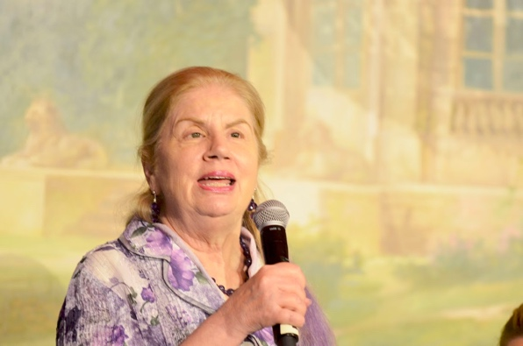

- On March 17, 2016, Stephanie Ortoleva and other WEI team and Board members were speakers at the CSW60 Side event WEI organized, entitled “Sustainable Development Goals or Sidelining Disabled Girls? Making SDGs Stand for All Women and Girls.” More details here: http://womenenabled.org/csw60.html

- In May 2016, Stephanie Ortoleva presented at the Women Deliver Global Conference in Copenhagen a talk entitled “Sexual and Reproductive Health and Rights of Women with Disabilities.” Click here to listen to the audio: http://womenenabled.org/reproductive.html#womendeliver2016

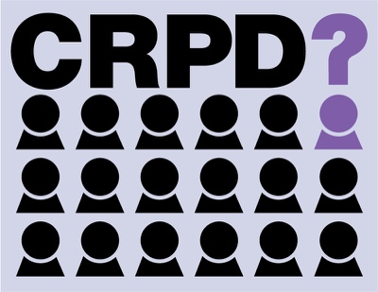
- In June 2016, WEI President Stephanie Ortoleva expressed outrage over CRPD Committee elections during the 9th Session of the Conference of States Parties to the CRPD. Watch a video clip here: http://bit.ly/2fFzivD Below, a photo of Stephanie with the other speakers at the COSP event.
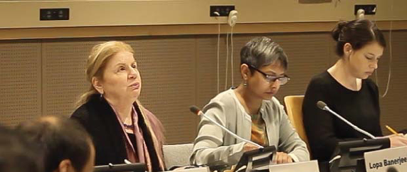

- In September 2016, Stephanie Ortoleva participated in the 13th Annual AWID International Forum in Brazil, where she organized a panel to provide training on WEI’s accountABILITY Toolkit and also organized a panel on Abortion stigma and Disability Stigma – Similarities and Differences, in collaboration with the Center for Reproductive Rights.

- On Thursday, September 29th, Stephanie Ortoleva participated in the event, "A Rights-Based Approach to Zika: Putting Women and Girls at the Center of the Global Response," organized by the Center for Health and Gender Equity Anis-Instituto de Bioetica, International Planned Parenthood Federation/Western Hemisphere Region, and Promundo-US, in partnership with the Embassy of Sweden. Watch Stephanie’s statement here.

Below left, Stephanie shares her statement with the audience and below right, Stephanie chats with Ambassador Björn Lyrvall of Sweden.

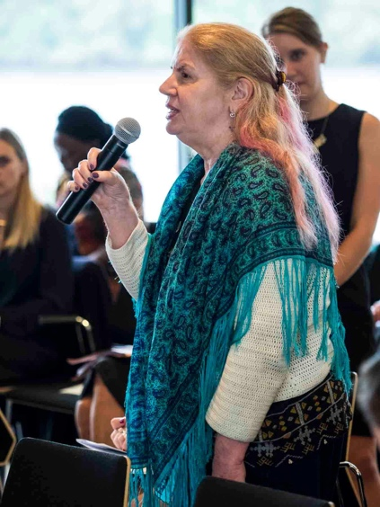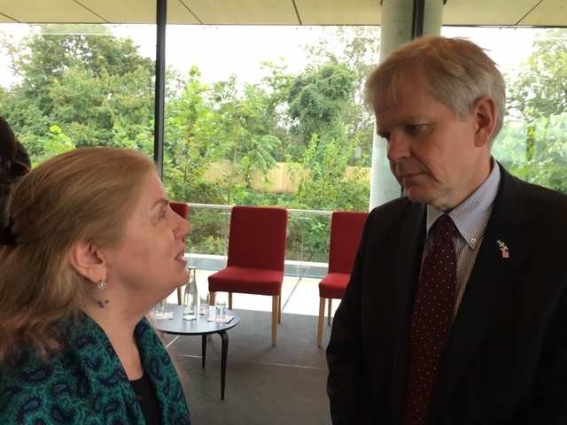

- In November 2016, WEI President Stephanie Ortoleva participated in an Expert Group Meeting called “Advancing the rights and perspectives of women and girls with disabilities in development and society” held in Santiago de Chile, Chile organized by The Division for Social Policy and Development (DSPD) of DESA with the United Nations Economic Commission for Latin America and the Caribbean (UNECLAC). At this meeting, Stephanie Ortoleva gave a presentation entitled “Accountability- Responding to Needs of Women & Girls with Disabilities in Disasters and Humanitarian Crises.” The meeting included experts from around the world including those with experience in: disability, women’s rights, gender equality and empowerment of women, social and economic development, and research. The meeting resulted in a set of recommendations to support operationalization of the 2030 Agenda for Sustainable Development, and other internationally agreed goals, in a way that is inclusive of and responsive to the needs and perspectives of women and girls with disabilities. The meeting also will contribute towards a Secretary-General Report on the situation of women and girls with disabilities.
For documents relating to the EGM as well as the forthcoming EGM Outcome Document, see: https://www.un.org/development/desa/disabilities/about-us/expert-group-meetings/egm2016_women_chile.html

Below, a photo of Stephanie sitting at the table in Chile.

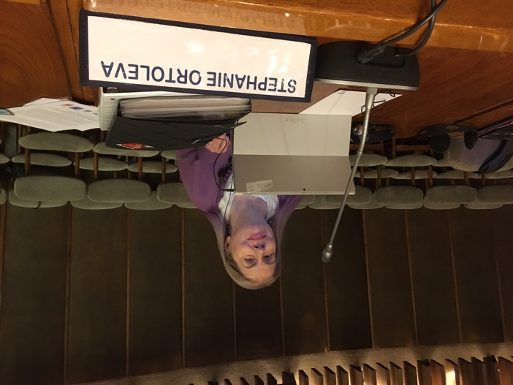

Current Publications

- In April 2016, WEI published, “Talking Points Zika, Microcephaly, Women’s Rights and Disability Rights.” This publication sets out a more nuanced perspective to frame a discussion that reflects the inherent rights and dignity of all affected by the Zika virus based on an intersectional disability and women’s human rights perspective. It is available in English, Spanish and Portuguese. The Talking Points can be found here: http://bit.ly/2kmXtzN

- In May 2016, WEI worked with the Human Rights and Gender Justice Clinic at CUNY School of Law to submit an amicus brief in the case of I.V. v. Bolivia before the Inter-American Court of Human Rights. I.V. a Peruvian political refugee, was forcibly sterilized during a cesarean section in 2000. This case marks the first time that the Inter-American Court will consider the human rights implications of sterilization without consent, a practice that is disproportionately perpetuated against women who encounter high rates of stigma, such as women living with HIV, poor women, ethnic or national minorities or women with disabilities because some health care providers believe that these women should not have children or that they are unable to make reproductive decisions on their own behalf. Our amicus brief emphasizes the severe physical and mental harms that forced sterilization imposes on women- 16 years after her sterilization, I.V. still acutely feels the emotional and psychological toll of having been sterilized without her consent- and analyzes prevailing international standards to demonstrate that forced sterilization is a form of cruel, inhuman, or degrading treatment and, in some cases, may amount to torture. We urge the Inter-American Court to join the U.N. and European human rights experts in recognizing the gravity of this human rights violation. The brief is available in English and Spanish. The brief is also available here: http://womenenabled.org/pdfs/I.V.%20v%20Bolivia%20Amicus%20Brief-HRGJ%20WEI.pdf

- In October 2016, WEI alongside local partners Advocacy for Women with Disabilities Initiative (AWWDI), Legal Defence and Assistance Project (LEDAP), and Inclusive Friends Association, submitted a shadow letter to the CEDAW Committee to help them develop a list of issues for its forthcoming review of Nigeria. The letter highlights that because of their disability and their gender, women and girls with disabilities in Nigeria face multiple layers of discrimination and stereotypes about their capabilities that mean they are given less priority in families, have less access to education, and are considered less eligible for marriage or to found families. This shadow letter concludes with several recommendations for the CEDAW Committee to include when developing the list of issues for tis review of Nigeria’s women’s rights record and for concluding observations following the review in July 2017. Read the PDF here or word document here.

- In November 2016, WEI prepared a short submission on the rights of women and girls with psychosocial disabilities sent to the Office of the High Commissioner for Human Rights (OHCHR) for a forthcoming OHCHR report on mental health and human rights. Following up on a Human Rights Council resolution on this topic, the OHCHR report will focus on violations of in the context of mental health provision and interpreting legal standards to ensure the respect, protection, and fulfillment of all human rights. WEI’s submission focuses on violations faced disproportionately by women and girls with psychosocial disabilities, including forced and coerced reproductive health procedures, gender-based violence, and barriers to accessing justice. It also provides interpretations of relevant articles of the CRPD and other human rights conventions, with recommendations about how states should implement these conventions to tackle human rights abuses against women and girls with psychosocial disabilities. Read the full submission here: http://bit.ly/2fTtvQQ

- In November 2016, WEI also submitted a short report on the rights of girls with disabilities to the forthcoming OHCHR report “Protection of the Rights of the Child and 2030 Agenda for Sustainable Development.” While addressing the question, “What approaches to implementing the 2030 Agenda would ensure the protection of the rights of all children, and that no child is left behind?” this report examines the disparities that girls with disabilities face in accessing education and exercising the right to health, including sexual and reproductive health. It also notes the higher rates of violence, including gender-based violence, against girls with disabilities, as well as barriers they face in accessing justice and participating in accountability mechanism. Finally, the report includes recommendation for how states can implement the Sustainable Development Goals in a way that respects, protects, and fulfills the human rights of girls with disabilities. Full text here: http://bit.ly/2gvI64W

- WEI and Women with Disabilities India Network Joint Submission to the Human Rights Council’s Universal Periodic Review of India
Available at: http://womenenabled.org/publications.html#WEIWWDIN92016
Women Enabled International, working with Women with Disabilities India Network, compiled this submission for India’s upcoming third Universal Periodic Review at the Human Rights Council in Geneva. Drawing on India’s international commitments, this submission focuses on violence against women with disabilities, access to sexual and reproductive health services, and access to justice. As the submission illustrates, women with disabilities in India disproportionately face violations of these rights, due to discrimination based on both their gender and disability and stereotypes about their capability, sexuality, and role within families. The submission provides targeted questions and recommendations on these topics for India’s UPR, which will take place in April/May 2017 in Geneva, Switzerland.

- WEI and Sisters of Frida Joint Submission to the Human Rights Council’s Universal Periodic Review of the United Kingdom of Great Britain and Northern Ireland. Available at: http://womenenabled.org/publications.html#WEISOF92016

Women Enabled International and Sisters of Frida, a collective of women with disabilities in the UK, compiled this submission for the UK’s upcoming third Universal Periodic Review (UPR) at the Human Rights Council in Geneva. This submission focuses on the continuing problem of violence against women with disabilities in the UK, as they face higher rates of sexual violence and experience domestic violence at twice the rate of other women. Women with disabilities are also less likely to have the economic independence to leave an abuser, have fewer accessible options for support services, and face increased barriers to accessing justice, due to disability-related stereotypes and denials of reasonable accommodation. The submission provides targeted questions and recommendations on these topics for states to utilize during the UK’s UPR, which will take place in April/May 2017 in Geneva, Switzerland.

- WEI Submission to the CEDAW Committee on its update to its General Recommendation No. 19 on Violence Against Women, with sign on support from eight non-governmental organizations around the world.
Available at: http://womenenabled.org/publications.html#WEICEDAWGR19.

This submission was drafted by Women Enabled International (WEI) and is endorsed by: Advocacy for Women with Disabilities Initiative (AWWDI) (Nigeria); Association of Disabled Women, ONE.pl (Poland); CREA (India); Legal Defence and Assistance Project (LEDAP) (Nigeria); National Union of Women with Disabilities of Uganda (NUWODU); Shanta Memorial Rehabilitation Centre (India); Sisters of Frida (United Kingdom); and Women with Disabilities India Network (WWDIN).

Based on the specific issues that women with disabilities experience when exercising their right to be free from violence, this submission provides targeted comments to the CEDAW Committee on its Draft update to General Recommendation No. 19 (1992): accelerating elimination of gender-based violence against women. These comments focus both on how to more explicitly include women with disabilities in the draft and also how to ensure that the draft’s provisions adequately address the barriers and issues that women with disabilities disproportionately face when exercising their right to be free from violence. As such, this submission provides both suggested amendments to the current paragraphs of the draft General Recommendation and suggestions for additional paragraphs and sections to include in the draft.

The amendments suggested in this submission are important for our work on the rights of women with disabilities for several reasons. Although many of the countries that have ratified CEDAW have also ratified the Convention on the Rights of Persons with Disabilities (CRPD), and the CRPD Committee recently issued a general comment on the rights of women and girls with disabilities that addresses gender-based violence, there is not a perfect overlap between states parties to the two conventions. Additionally, although the CRPD Committee has weighed in on many of the issues that lead to violence against women with disabilities—including denying them legal capacity and arbitrarily detaining them in institutions, based on disability—many states have not fully adopted the human rights-based approach to these issues and still allow, and frequently legally permit, these violations to take place.

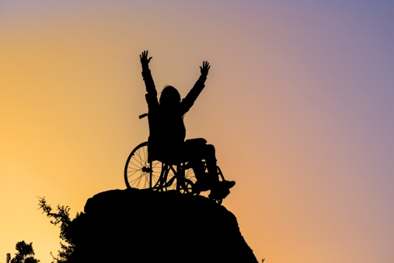
As the CEDAW Committee is the human rights leader in efforts to eliminate violence against women, many states and our organizations would benefit from the CEDAW Committee’s additional guidance on these issues. Finally, by ensuring that women with disabilities are better included in the updated General Recommendation No. 19, the CEDAW Committee will be recognizing the unique experiences of women with disabilities while also including them in the framework of women’s rights, helping to reduce stigma targeted at women with disabilities by ensuring that their experiences are no longer invisible and that they are fully recognized as women and as rights holders.

Proposed New Proposed Initiatives for 2017 for which
WEI is Seeking Funding:

- Women Enabled International seeks to develop a media project that invites women and girls with disabilities, from every part of the world, to create and share a personal film or photo and written or audio narrative about her actions to end violence against women and girls with disabilities, as well as her personal story of surviving and thriving after the violence. Ten submissions will be selected from those received, edited together into one film, and presented at an appropriate venue, such as the United Nations Commission on the Status of Women as well as at other venues. Additionally, finalist submissions will be displayed on WEI’s website, and through WEI’s social media platforms, for the world to learn the power and creativity of women and girls with disabilities worldwide and to raise awareness about violence against women and girls with disabilities, who are two to three times more likely to experience gender-based violence and abuse as non-disabled women.

- “Shifting the Tone, Showing Respect, Ensuring Inclusive Reproductive Health Care,” this project will engender a more inclusive reproductive justice movement by developing tools and communication strategies, in consultation with stakeholders in the international women’s rights and disability rights communities, focused on the SRHR of all women and girls, including women and girls with disabilities

- International Convening in other regions including Africa, South Asia, the Middle East/North Africa, and the Far East

- Quarterly webinars on the accountABILITY Toolkit

Social Media

- As of December 21, 2016 WEI’s Twitter account has 2,389 followers, the Facebook account has 1,447 followers and the WEI LinkedIn account has 306 followers.

- We have strategies in place to continue boosting our profile(s) and reach on all three channels in 2017. Below is a table that outlines our growth on social media between 2014 and 2016.

Platform | 12/31/14 | 12/31/15 | 12/31/16
Twitter | 904 | 1,444 | 2,387
Facebook | 598 | 1,004 | 1,449
LinkedIn | 70 | 126 | 312

Our strongest social media platform is still Twitter, following Facebook and LinkedIn. The gains that we made with our Twitter followers in one year is close to 1000, which is remarkable in comparison to the other social media platforms. Below, a photo of Stephanie Ortoleva and Ashley Pusey, Social Media Director.

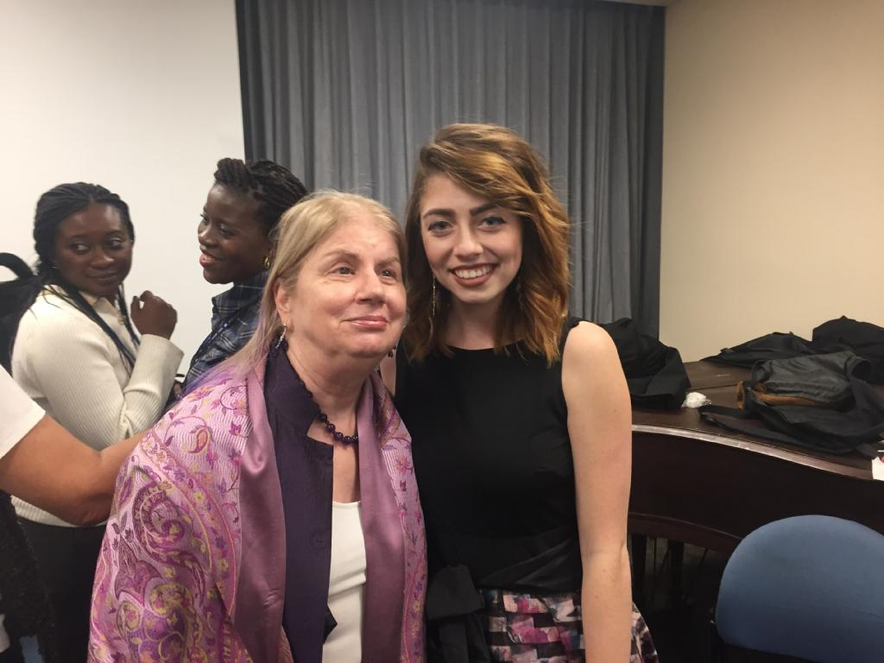

Please consider Women Enabled International for your support!
Your charitable contribution will help Women Enabled International's mission of advancing the human rights of women and girls worldwide, especially women and girls with disabilities. WEI is actively pursuing funding for specific programs and projects for 2017, as well as for general support. Donations may be made online and are tax-deductible to the extent allowed by law. Thank you for your support of WEI!

Stephanie Ortoleva, Esq.
Founder and President, WomenEnabled International
1875 Connecticut Avenue, 10th Floor
Washington, D.C. 20009, United States
************************************************************************
Check out updates on our website, follow us on Twitter, find and like WomenEnabled on Facebook, watch us on Instagram at WomenEnabled, and connect on LinkedIn for information on human rights, women’s rights and the rights of women with disabilities internationally.

